Curriculum Vitae

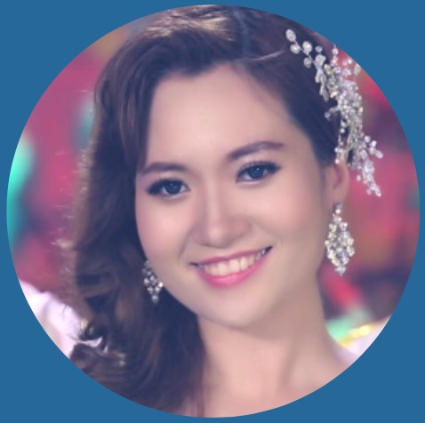
My Hoan Nguyen
6 Meadow Lands
Petersfield, Hampshire, GU32 3PX
(+44) 7387 500 470
nicepianist@yahoo.com https://www.linkedin.com/in/maria-my-nguyen/

Personal Statement
My goal is to work and expand my music career to an international level. All my family are talented musically and I was encouraged at an early age. In Vietnam I participated in Vietnam’s Got Talent as a vocalist and pianist when I was 17. Later, as a lead singer I made a half-dozen professional music videos sponsored by perfume companies. My stage name is Hoan My Piano.
I am currently in my third year at the University of East London, where I am taking courses to earn a BA (Hons) Music Performance and Production. Alongside University I take part in musical activities, such as performing at open mic-nights around London including Nambucca Venue, Underground Bar, Opening day at UEL campuses and performing live New Year Events.
I can compose and produce music with Digital Audio Workstations like Ableton Live and Logic Pro as well as creating attractive websites using Photoshop, I am comfortable with Microsoft Office and adept at making music videos for YouTube using various video editing programs in order to target the market. I am a hard worker and quick learner.

EDUCATION & QUALIFICATION
2020 – 2022 University of East London (UEL) / London, United Kingdom
BA (Hons) Popular Music Performance and Production degree
Modules: Year 1 (Level 4) - Music Performance and Production Technique
- Collaboration
- Public Project
- Professional Life
Year 2 (Level 5) - Music Performance and Production Craft
- Multidisciplinary Collaboration
- Public Project
- Music Performance and Production and Craft
- Professional Life
Year 3 (Level 6) - Music Performance and Production Advanced
- Practice and Innovation
- Final Project: Research and Development
- Public Project
- Practice and Enterprise
- Final Project: Engagement and Impact
- Professional Life
2019 – 2020 The Institute of Contemporary Music Performance (ICMP), London, United Kingdom
Higher Diploma in Music Performance
Modules: - Singing
- Music Composition and Production
- Music Theory
- Developing Instrumental Techniques
Associated Board of the Royal Schools of Music (ABRSM)
Piano Practical and Music Theory
HIU - Hong Bang International University, Vietnam
Studied tourism and hotel management and improved my English skills. Earned a Professional College Diploma
VNUHCM - University of Science
Computer Science
Modules: - Microsoft Office 365
- Microsoft Word
- Excel
- PowerPoint
- Databases (MS Access)
- Spreadsheets (MS Excel)
- Word Processing (MS Word)
- Operating Environment (MS Windows)
- Computer Literacy
WORK EXPERIENCE
GMC MUSIC - NHAC XANH 2016 - 2019
Singer/ Soloist

PRIVATE PIANO TEACHER & PIANIST 2010 - Present
Part - time: Tutor & Pianist

PL MODEL- VIETNAM'S TOP MODELLING AGENCIES 2012 - 2015
Part-time: Modelling, Fashion Model, Acting

ACTIVITIES
NAMBUCCA VENUE LONDON 2019 - 2021
Lead Singer + Backing Vocal
VIETNAM'S GOT TALENT 2011
Performer Solo Piano + Vocal
CHA TAM CHURCH 2002 - 2018
Choir / Vocalist / Reading bible
SKILLS
Music Educator, Composition, Musical Theatre, Performance
Office, Computer Science, Network, Teamwork, Accounting, Logical thinking and creative, Public Speaking, Linguist, Business Development, Human Resources, Art, Graphic Designer
Logic Pro, ProTools, Reaper, Cubase, Sibelius, Guitar Pro, Photoshop, Illustrator,
Premiere, After Effects, InDesign, Flash, ZBrush, GameMaker, Unity, Cinema 4D, PowerPoint, Word, Excel, Kanban, Windows, Mac, HTML, CSS, Wwise, FMOD, Social Media, Website Designer.
Fluent in Vietnamese and English.

REFERENCES
Dr Helen L Reddington
Senior Lecturer
Music Production and Culture
University of East London
Email: h.l.reddington@uel.ac.uk

